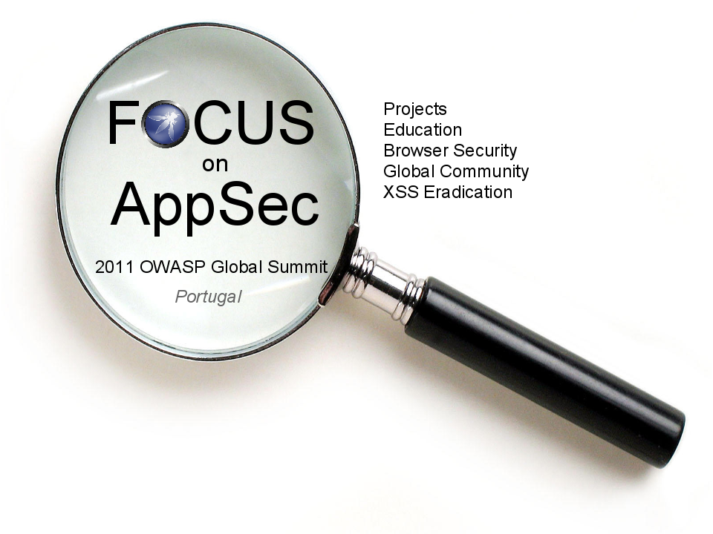
OWASP Foundation
9175 Guilford Road, Suite #300
Columbia, MD 21046
+1-301-275-9403 (phone)
+1-301-604-8033 (fax)

Questions about the Summit?
Lorna Alamri
lorna.alamri@owasp.org
Sarah Baso
sarah.baso@owasp.org
Jason Li
jason.li@owasp.org

Dear <INVITEE NAME>,

The Open Web Application Security Project (OWASP, http://www.owasp.org) cordially invites you to participate in the 2011 OWASP Global Summit in Portugal, February 8 through 11, 2011. This year's Summit will be a worldwide gathering of OWASP leaders as well as key industry players and involve focused discussion of university outreach in addition to browser security and cross-site scripting eradication.

During the university outreach working session, we hope to bring OWASP educational supporters together and address questions such as:
  - What security education programs currently exist in university settings around the world?
  - How can OWASP participate and influence the curricula of these educational programs?
  - How can we foster relationships between OWASP and universities?
  - How can the relationship between OWASP and universities be standardized?
  - What can OWASP offer universities and what can they, in turn, expect from each other?

The cost to attend the Global Summit is approximately $1,200.00 + airfare. We believe that attending the Global Summit is an worthwhile investment for both you and <UNIVERSITY NAME> as a whole. If you will need assistance in securing funding, please let us know as soon as possible. We recommend that you consider asking either <UNIVERSITY NAME> or <your local OWASP chapter/project> to support your participation.

More information on the venue and logistics can be found on the Summit’s website,
http://www.owasp.org/index.php/Summit_2011

Please let us know by <RSVP DATE> if you will be able to attend the Summit so we can ensure that are adequate accommodations. We look forward to hearing from you!

Best Regards,

OWASP

