Help OWASP Pick 3 Supporter Logo's

In accordance with our trademark and brand usage guidelines ( <https://www.owasp.org/index.php/Marketing/Resources#tab=BRAND_GUIDELINES> ) OWASP Foundation has created (8) logos and needs your help in picking (3) by rough consensus by April 15th, 2016.   
  
The finalists logos will be approved and made available to all individuals and companies worldwide to use in support of the OWASP Mission "... to make software security visible, so that individuals and organizations worldwide can make informed decisions about true software security risks." and use them in ANY form of awareness including Print, Online, Blogs, Stickers, Widgets etc..etc..   
  
Have additional questions about membership see: <https://www.owasp.org/index.php/Membership>

\* Required

Option 1

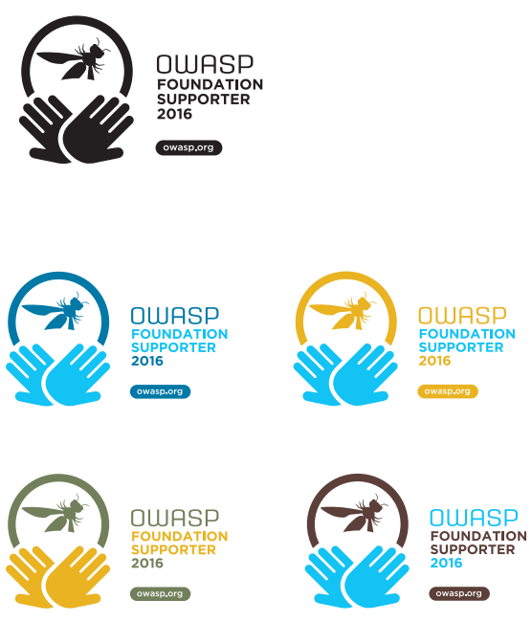

Option 2

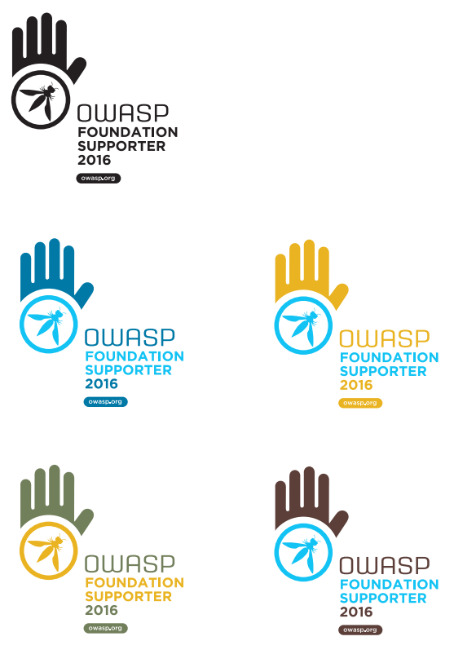

Option 3

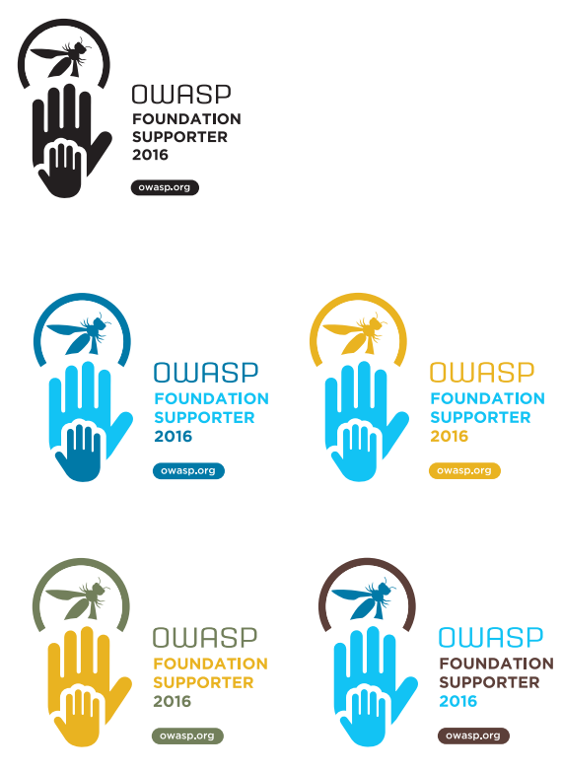

Option 4

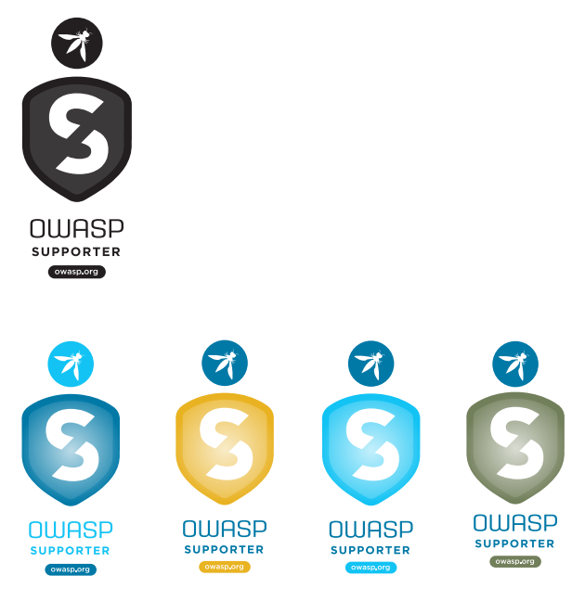

Option 5

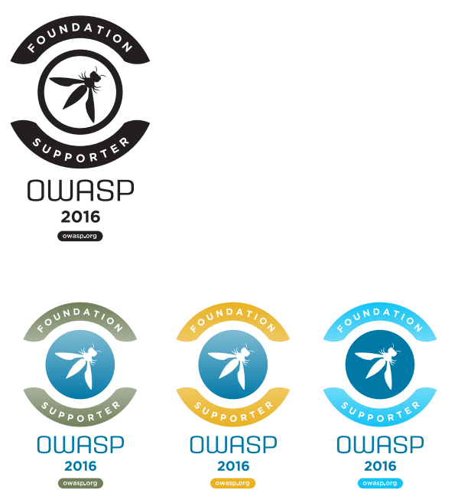

Option 6

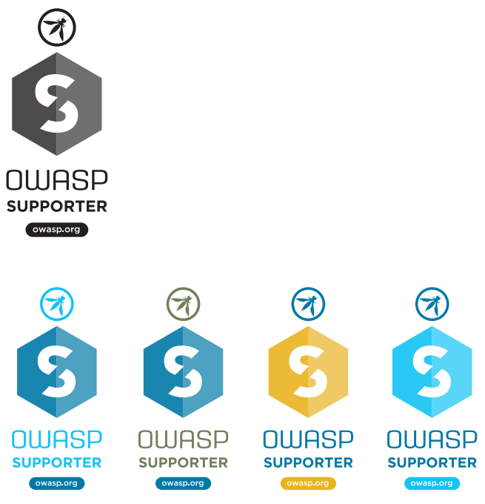

Option 7

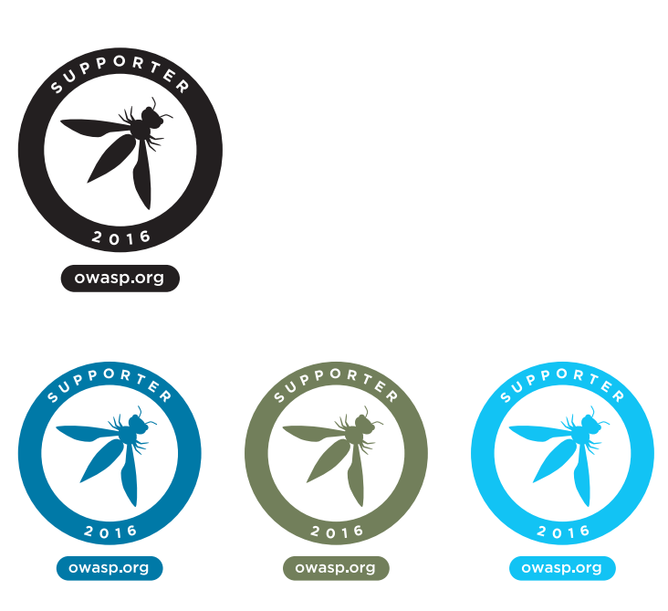

Option 8

